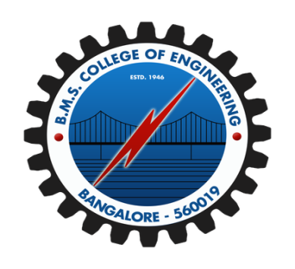

**B M S COLLEGE OF ENGINEERING**

**(Autonomous college under VTU)**

**Department of Computer Science and Engineering**

**Phase Shift-2018 (National Technical Symposium)**

**EVENT**

***“RESCUE MISSION HACKATHON”***

|  |  |  |  |  |
| --- | --- | --- | --- | --- |
|  |  |  |  |  |

**Conducted on 16th September 2018 from 12.00 pm to 5.00pm as part of Phase Shift 2018**

**Organized by**

Department of Computer Science and Engineering, BMSCE Protocolin collaboration with BMSCE IEEE

**VENUE: CSE lab-2, BMSCE**

**FACULTY COORDINATORS:**

**Asha G R Dr. Kavitha Sooda Dr. B. G. Prasad**

**Assistant Professor Associate Professor Head of Department**

**Dept of CSE, BMSCE** **Dept of CSE, BMSCE Dept of CSE, BMSCE**

**STUDENT COORDINATORS:**

**Eleanor Prashamshini Nitesh Srivats**

**1BM16CS005, CSE 1BM17CS037, CSE**

**REPORT ON RESCUE MISSION HACKATHON**

Rescue mission hackathon was an event conducted under the Computer Science and Engineering Department of BMSCE in collaboration with BMSCE IEEE. It was an event which was based on the theme Space Systems. The event was conducted on 16th September, 2018 from 12:00 pm to 5:00 pm. The event had 10 registrations in total some of whom were IEEE members and students were allowed to participate as individuals or in teams of two or three or four.

**SCHEDULE OF THE EVENT**

|  |  |  |
| --- | --- | --- |
| **Start Time** | **End Time** | **Description** |
| 12:00 | 12:30 | Welcome and Introduction |
| 12:30 | 16:30 | Conduction of competition |
| 16:30 | 16:40 | Announcing results and general feedback |
| 16:40 | 16:50 | Handing over the prize money and certificates to winners and runners |
| 16:50 | 17:00 | Photo session with the contestants |

The rescue mission hackathon was a coding event and was designed to test the knowledge of the participants in the field of Space Systems.

There were participants from different colleges and who were in different semesters. They were given opportunity to code in the language they were comfortable with.

Results were decided based on many factors. Their code and output was checked thoroughly for accuracy and precision. Space and time efficiency was also taken into consideration. There was a close margin between the teams. At the end of the event prizes were distributed to the winners.

**DETAILS OF THE PARTICIPANTS**

|  |  |  |  |  |
| --- | --- | --- | --- | --- |
| **Team**  **No** | **Name** | **Email id** | **College** | **Ticket no** |
| 1 | Rohith AC | rohith.cs18@bmsce.ac.in | BMSCE | OR-27-30 |
| Naman Agarwal | naman.cs181bmsce.ac.in | BMSCE |
| Tanul Mudgal | tanul.cs18@bmsce.ac.in | BMSCE |
| 2 | Ketaki Vinod Patil | ketakipatil98@gmail.com | RNSIT | AT-16 |
| P Yuktha | polepalliyuktha99@gmail.com | RNSIT |
| Swathi N Rao | swat.smar@gmail.com | BIT |
| 3 | Akash C | akashincrp@gmail.com | JSS | DE-08 |
| Hrishikeh M | Vid.hrish@gmail.com | JSS |
| 4 | K S Lohith | Kslohith1729@gmail.com | MSRIT | Online- 550 |
| V R Karthik | vrkarthik14@gmail.com | MSRIT |
| Vybhav Jain | vybhavjain_1998@gmail.com | MSRIT |
| 4 | Sagar Rugadi | Sagarrudagi.cs17@bmsce.ac.in | BMSCE | BO09 |
| Sudarshan S | senthilsudarshan@gmail.com | BMSCE |
| Romil K Balar | romilbalar100@gmail.com | BMSCE |
| Rohan Mayya | rohanmayya@gmail.com | BMSCE |
| 6 | Sumukh Nadig | Sumukh.nodig98@gmail.com | BMSCE | BV31 |
| Yashank R S | rsyashu@gmail.com | BMSCE |
| Yashas Prashanth | yashaprash@gmail.com | BMSCE |
| 7 | Krishna Prasad V | krishnaprasadv8@gmail.com | BMSCE | BV30 |
| Anirudh Tantry G | anirudh.ec18@bmsce.ac.in | BMSCE |
| Nisdhish Lakshinana | nidhish.ec18@bmsce.ac.in | BMSCE |
| 8 | Khrithik | khrithik1502@gmail.com | BMSCE | OR-27-36 |
| 9 | Paras | paras.s.khurana@gnail.com | PESU | AN-04 |
| 10 | Vishnu | vishnu.gambhir1@gmail.com | PESU | DF-01 |

**FEW SNAPS FROM THE EVENT**

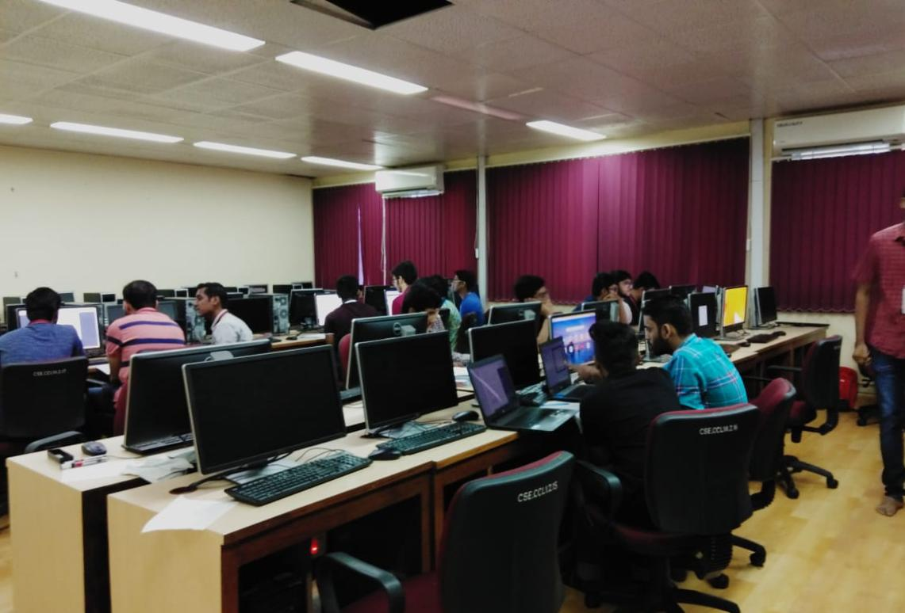

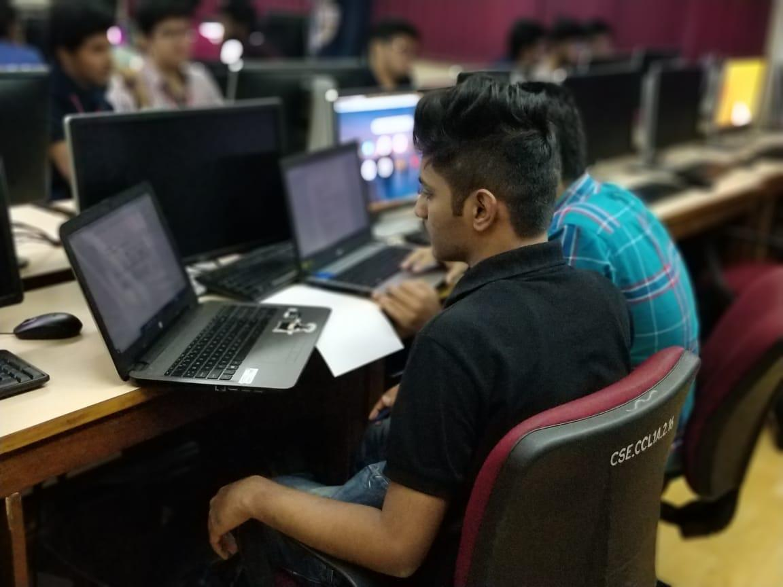

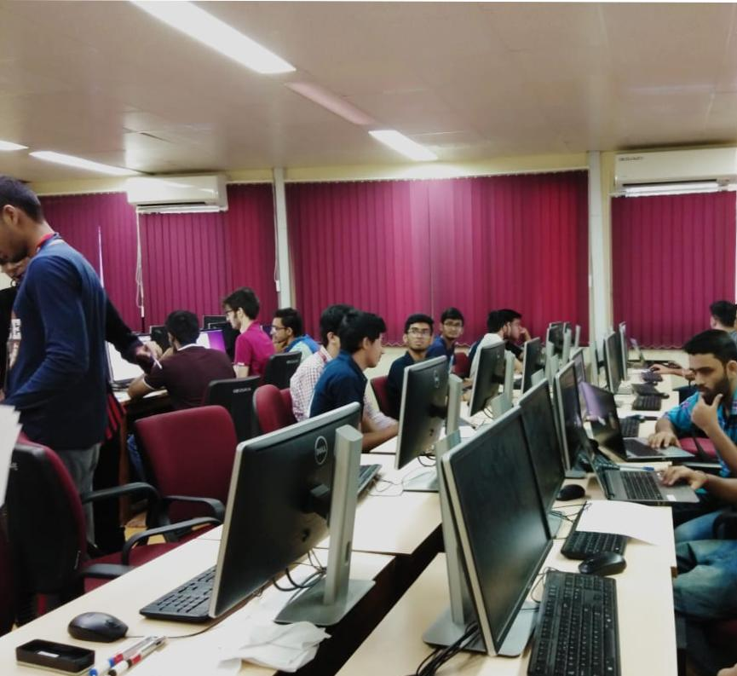

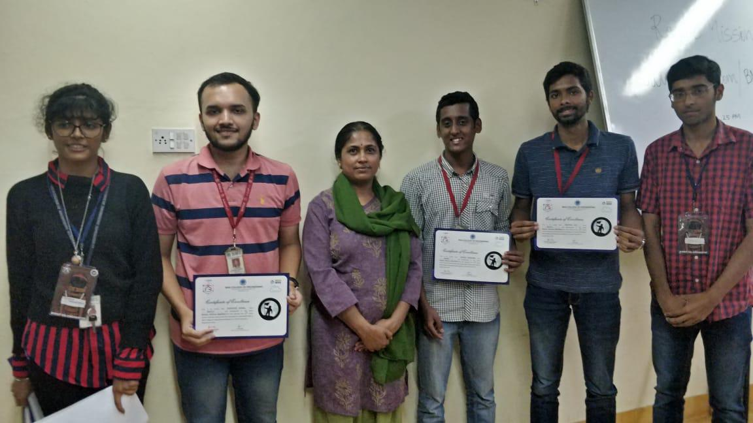

**PRIZES AND CERTIFICATES AWARDED**

The winner of the hackathon received **Rs.3000**. The runners-up received **Rs.2000.** All participants were awarded a certificate of participation from BMSCE Phase Shift.

**OBSERVATIONS AND REMARKS BASED ON FEEDBACK**

1. Question set received overwhelmingly positive feedback from most participants.
2. Some students were confused with the data. These aspects were taken care by the coordinators and volunteers.
3. Every participant was happy with the way event was conducted and hoped such events continue to take place in the future.

**FEEDBACK TAKEN FROM THE PARTICIPANTS**

